How to use Schedule Builder
Schedule Builder gives students the flexibility to plan their classes around their jobs, sports activities, and student life. With Schedule Builder, the students can take control of their schedule. These instructions will guide you through the steps to use Schedule Builder.

Navigate to the Advisee Student Center:

Self Service > Advisor Center > Advisee Student Center
 | On the search page opens,  - In the ID, enter the student’s CSUB ID  - Click the button to continue. | 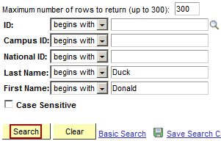
 | When the Advisee’s Student Center opens,  - Click the Schedule Builder link | 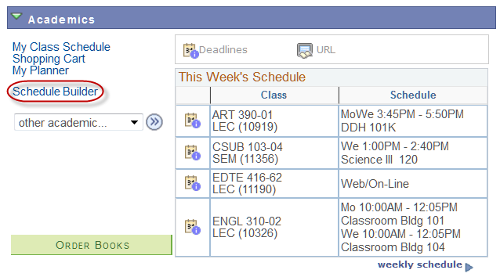
 | When the Scheduler Builder page opens,  - Click the button | 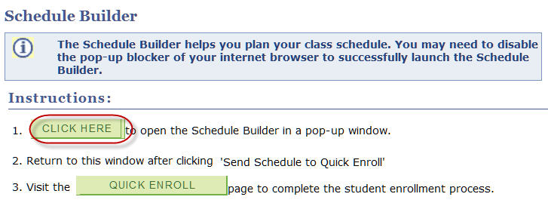
 | When the page appears,  - Click the down arrow  - From the list select a term, such as Spring 2014 | 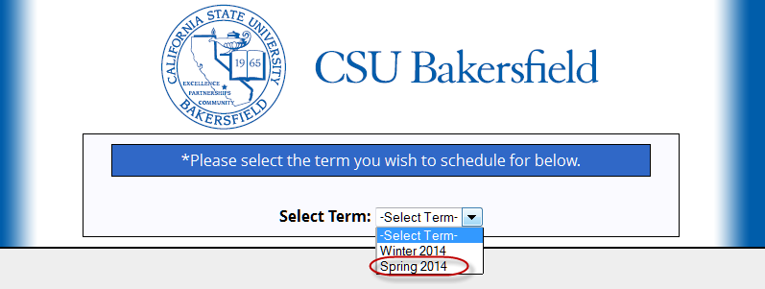
 | The Schedule Builder page opens,  - Click the button | 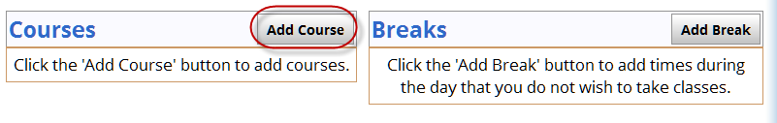
 | On the Add Course page,  - Select a Subject, such as Spanish  - Select a Course, such as Spanish 101 | 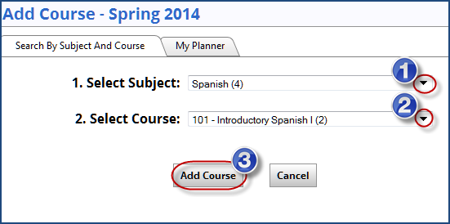
 | The course is added to your course list. To add another course, click the button. | 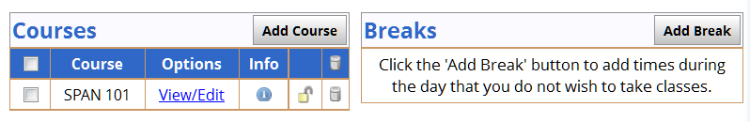
 | To add a break, click the button. | 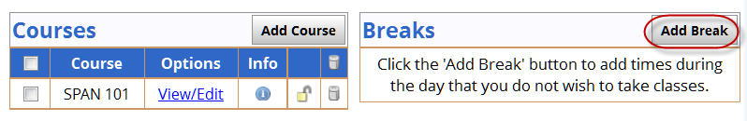
 | On the Add Break page,  - In the Break Name: enter a meaningful name for your break, such as Work  - In the Start Time, select the desired start time  - In the End Time, select the desired end time  - In the Days, select the days that you desire  - Click the button | 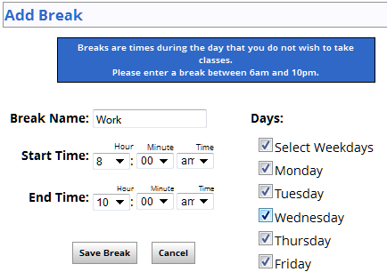
 | With the courses and breaks added, it is time to generate your schedules. To do so,  - Click the box beside the courses you want to include  - Click the button. | 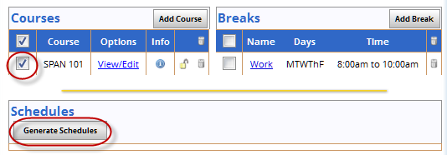
 | The schedules appear. From this list, you can  - Click the View link to view a Schedule  - Hold your cursor over the to preview a schedule  - Check one or more schedules to compare them. | 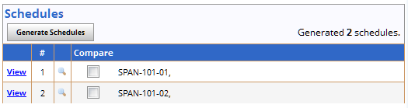
 | Once you decide upon a schedule, click the View link. | 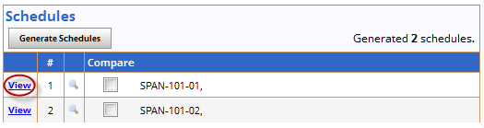
 | On the View Schedule page,  - If you security role permits, click the button and continue with step 15.  - Otherwise, click the button and skip the remaining steps.  If your security does not permit you access to Quick Enroll, the do not click the Send Schedule to Quick Enroll button. It will produce an error. | 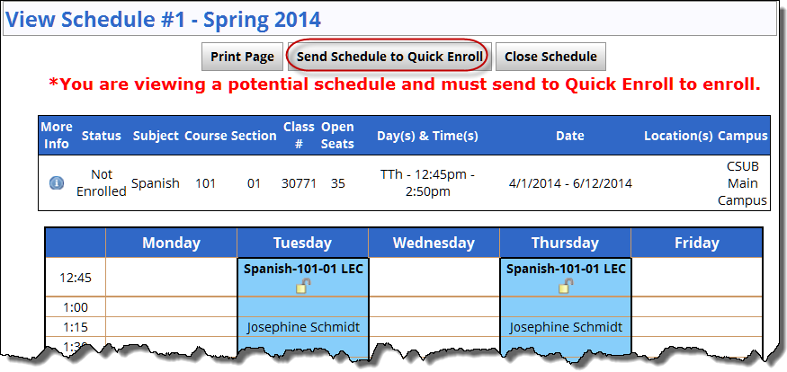
 | IWhen the informational message appears,  - Click the button | 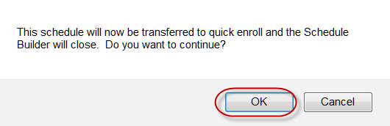
 | After you receive the Thank you message, return to the Schedule Builder page | 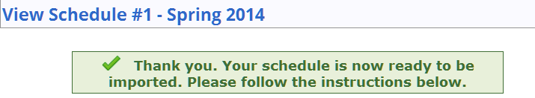
 | On the Schedule Builder page,  - Click the button | 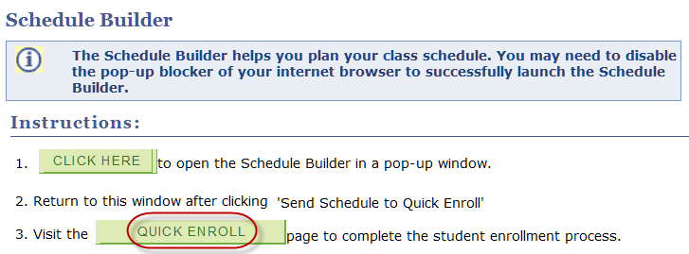
 | Your selected course(s) appear in Quick Enroll. From here, you can complete the registration process. | 